**University of Michigan – Dearborn**

**CIS 200 – Computer Science 2**

**Lab# 2**

Quan Le

[lmmquan@umich.edu](mailto:lmmquan@umich.edu)

October 1, 2024

**Table Content**

Contents

Question 1 3

Source Code 3

Description 3

Validation 3

Structures 3

Arrays 3

Screenshots 4

Design 6

Testing 7

Challenges 7

# Question 1

## Source Code

The source code for this question has been uploaded to Canvas as Lab_2.cpp.

## Description

This program manages employee records, it stores each employee’s ID, name, department and position in a class format.

## Validation

* ID : must be a string which is greater than 0
* Name : Ensure that the name is not empty and contains only alphabetic characters and spaces.
* Department : Ensure that the department is not empty and contains only alphabetic characters and spaces.
* Position: Ensure that the position is not empty and contains only alphabetic characters and spaces.

## Structures

* Define an Employee class with id, name, department and position (string)

## Arrays

* Use an array name emp to store up to 10 employee records, each represented by an Employee class.
* Data storage block : Store valid inputs in the array of Employee records
* Output handling block : Output the details of employees’ records, add a new employee, delete an employee

## Screenshots

Testing case 1:

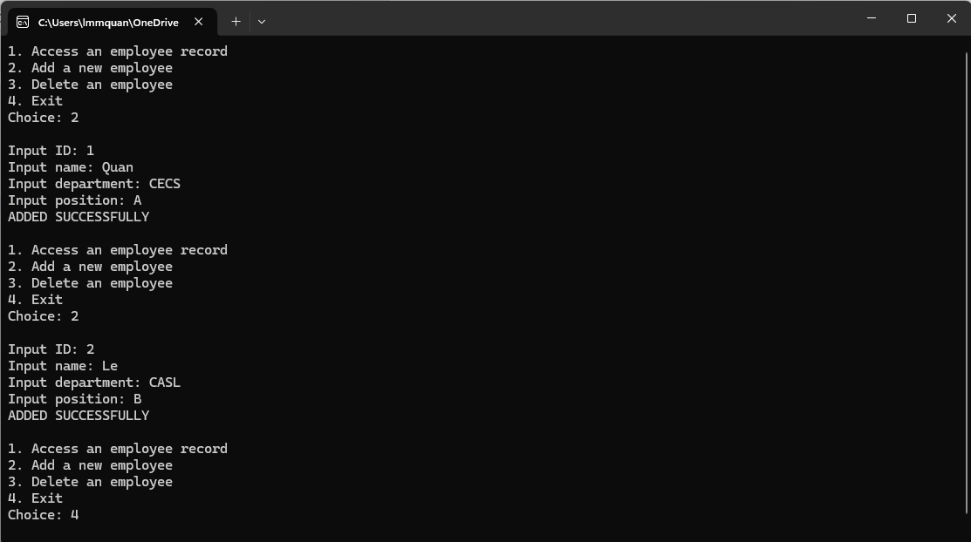

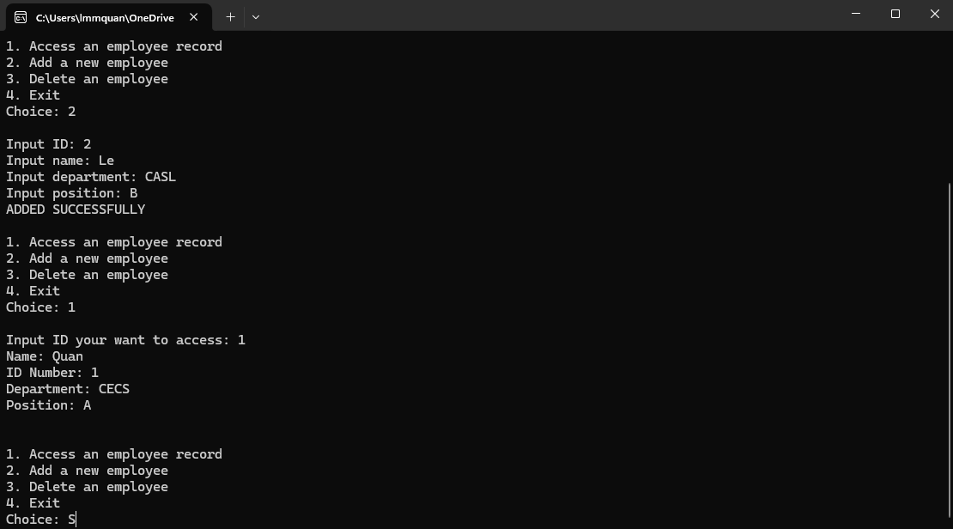

Testing case 2:

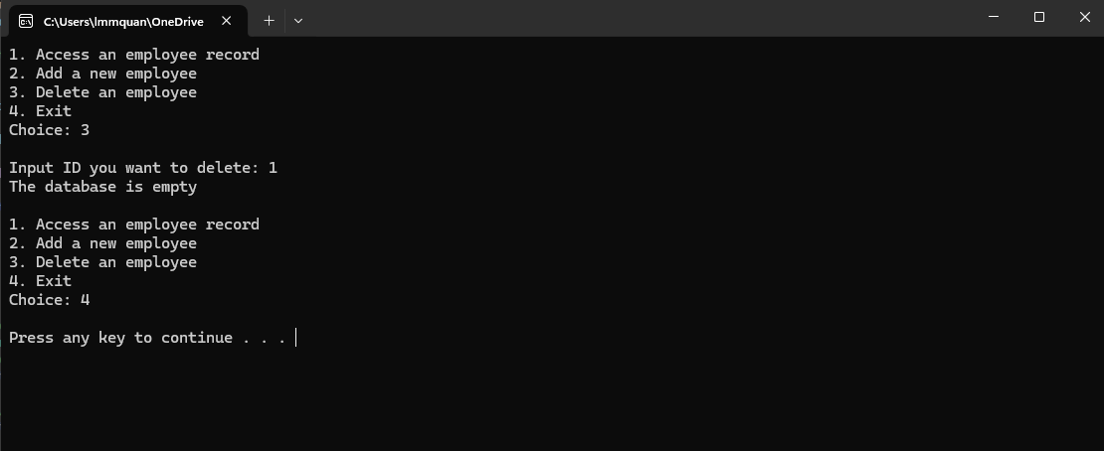

Testing case 3:

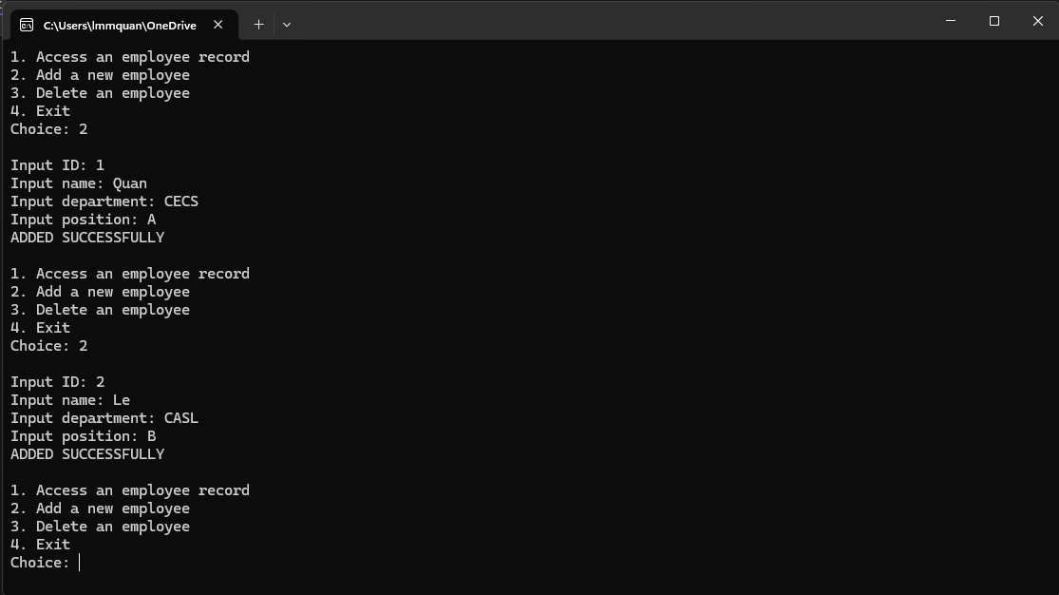

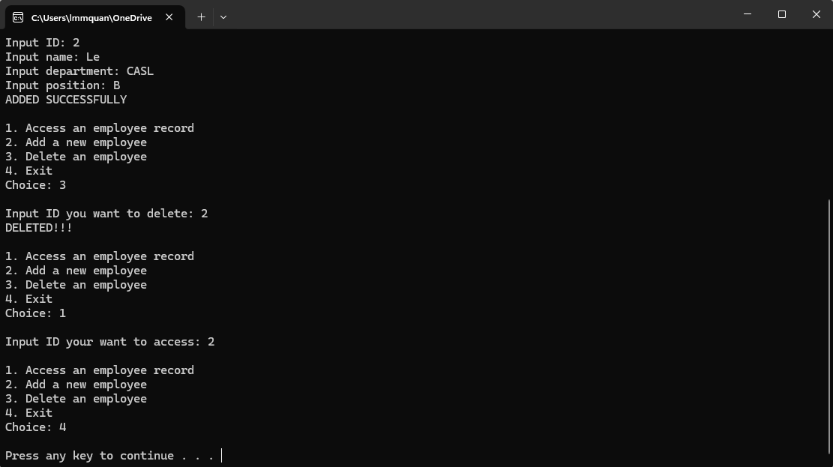

# Design

Declare variables

class Employee

User inputs details

Program call functions to output a menu of choices

Program calls functions to access, delete and add new employees

# Testing

|  |  |  |  |  |
| --- | --- | --- | --- | --- |
| Test # | Input value | Expected output | Actual output | Test Pass/Fail |
| 1 | Employee 1 : Quan, 1, CECS, A  Employee 2 : Le, 2, CASL, B | Access ID 1  Output all details of the ID1  Exit | Access ID 1  Output all details of the ID1  Exit | Pass |
| 2 | No input | Delete ID 1  Output “The database is empty”  Exit | Delete ID 1  Output “The database is empty”  Exit | Pass |
| 3 | Employee 1 : Quan, 1, CECS, A  Employee 2 : Le, 2, CASL, B | Delete ID 2  Output “DELETED” and the record of ID 2 is deleted  Exit | Delete ID 2  Output “DELETED” and the record of ID 2 is deleted  Exit | Pass |

# Challenges

* Infinity loop when the menu choices
* Check the duplicated ID
* Check the empty database
* Delete the given employee. I got the last 2 elements duplicated but managed to fix it and the elements got out of the array’s limit